Addition of 2d and a 1-digit number | Subtraction of a 2d and a 1-digit number
Encourage children to count forwards. Children can draw a blank number line to help them count forwards and to ensure they don’t make a mistake.  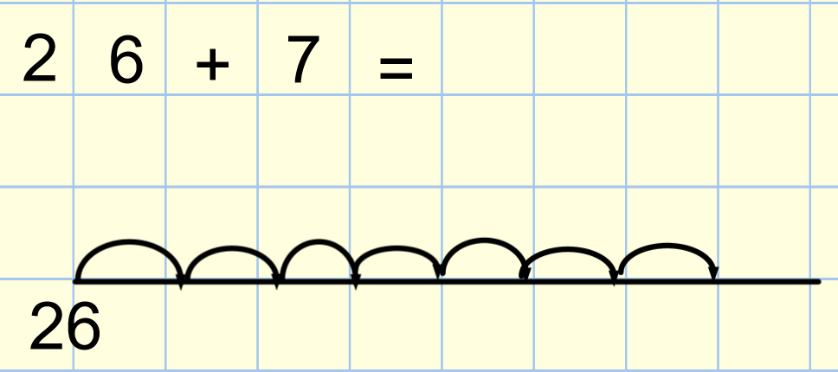 | Encourage children to count backwards. Children can draw a blank number line to help them count backwards and to ensure they don’t make a mistake.  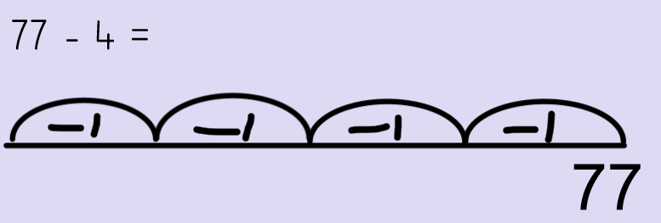
Addition of two 2 digit numbers.

Without carrying a ten:  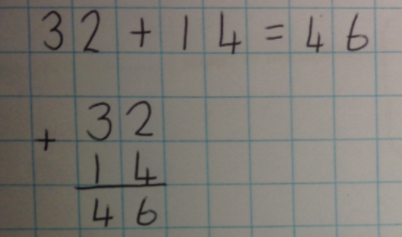 | With carrying a ten:  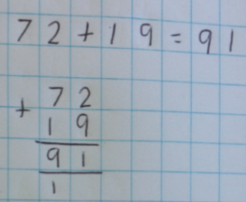
Subtraction of two 2 digit numbers.

Without exchanging:  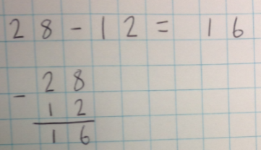 | With exchanging (borrowing) a ten:  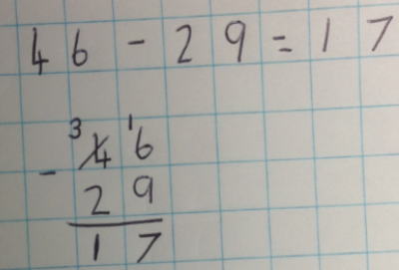
Multiplication: Drawing an array (if they cannot count in either 2’s,5’s or 10’s) | Division: Sharing circles ((if they cannot count in either 2’s,5’s or 10’s)
5 x 3 or 3 x 5 (the children know how to count in 5’s so this way is easier to count) | 6 ÷ 2 is 6 shared between 2 equal groups.  Children can count in their 2’s to find out how many go into 6 or draw sharing circles.  