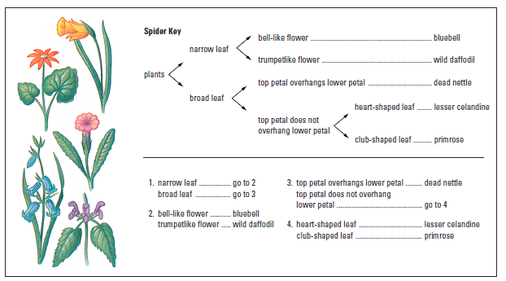
Good morning year 6, I hope you are all staying well and staying positive! If you looked at last Friday’s task, then you will now know how to examine leaves and be able to describe their shape and features. This week we are going to use this information to read different kinds of keys. If you follow both of these keys, you will be able to work out the names of the 5 flowers on the left of the picture!
5
4
3
1
2
What do you think they are called?
1)
2)
3)
4)
5)

The next type of key to look at is a Dichotomous Key. This is where you start at number one and read the description while looking at the first picture. Decide which of the two choices is the best answer for that leaf and then move on to which ever step it says, until you get to the name of a plant. The key is on the next page down. There are seven to have a go at on this key. Write your answers here:
1)
2)
3)
4)
5)
6)
7)
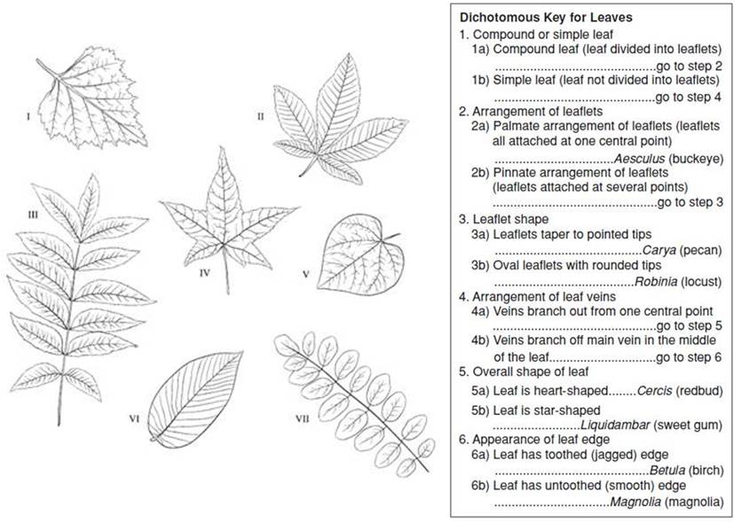
1
3
2
4
6
7
5
Now look at these leaves. They are all found commonly in this country. They are all trees. Perhaps you have one or more in your back garden? Have a look today and breathe in some fresh air!! I have holly and Ivy in my back garden.

Make your own leaf key:
- You have been given pictures of 6 leaves.
- Look carefully at each of the pictures and think of features that make each leaf different from each other.
- Think about things that will help you separate different groups, e.g. Does it have lobes? How many? Networked veins? Does it have prickles? Serrated edges? Remember – each question you ask should have a yes or no answer! Look back at last week’s lesson for more examples.
- Using the features on your list, try and make your own classification key that would help somebody who has never seen the leaves in your pictures to identify them.
- Once you have made your key, you need to test whether or not it works!

You will have to draw this on a piece of paper, but then you can save it to show me when we meet again!

Have fun!
Mrs Prentice x

