LI: To understand what kosher means.

If you can, print this sheet. If not, you can make some notes on another piece of paper.

Part 1
What is your favourite food?

List some occasions when we eat special food. What sort of food do we eat on those occasions? (Think about birthdays, Christmas, family traditions, or, if you attend a place of worship or have a faith, any special meals or celebrations you follow).

Part 2
In Judaism, there are rules about the food Jewish people can eat. These are called Kosher rules. God gave these rules to the Jewish people as one way of showing they were his holy (separate) people and different to those who did not worship him.

These are some of the rules about meat:
- Can eat animals which have a cloven hoof and chew the cud;
- Can eat animals which have both scales and fins;
- Animals have to be slaughtered in a particular way to reduce pain;
- Cannot eat milk (dairy products) at the same time as meat;
- You must not eat birds of prey.

Using these rules, label these pictures to show which are Kosher (which one Jews can eat) and which are not.

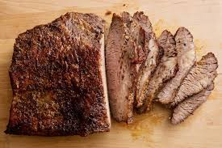
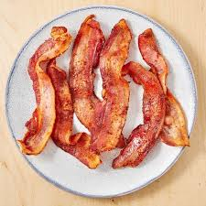
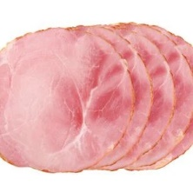
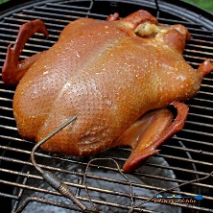
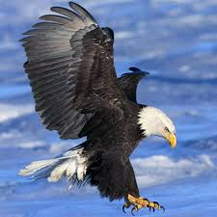
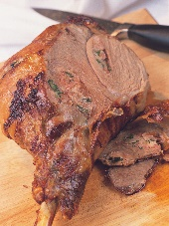
roast beef
bacon
ham
salmon
cheeseburger
duck
eagle
shark
roast lamb

