
CONFIDENTIAL

SUPPORT STAFF APPLICATION FORM
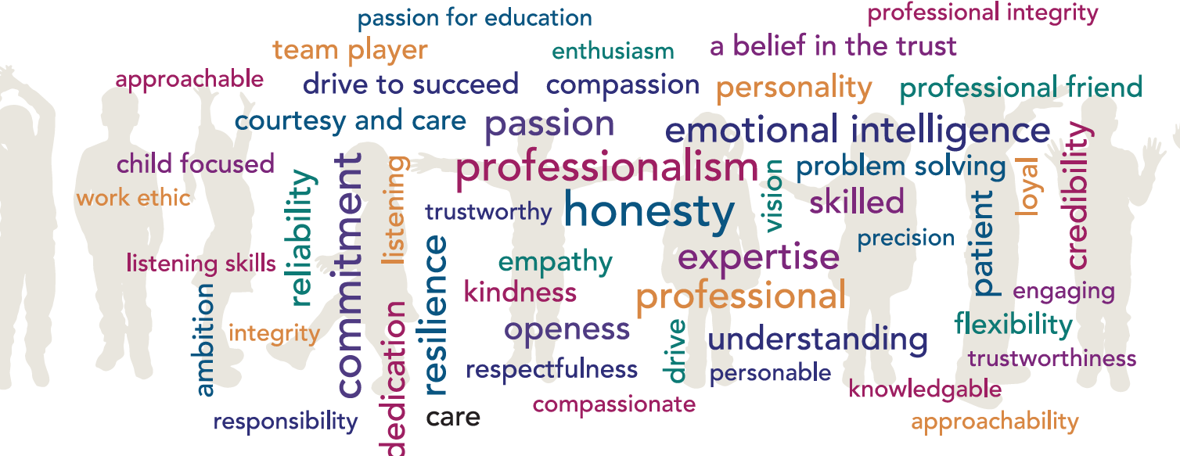
Please use black pen when completing this form
Application for the post of
Advertised at school
Applicant's details
Last name |  |  |  |  |  |  |  |  |  |  |  | First name
Any other last names |  |  |  |  |  |  |  |  |  |  |  | Title
Address
 |  |  |  |  |  |  |  |  |  |  |  |  |  |  | Postcode
Day time contact no. |  |  |  |  |  |  |  |  |  |  |  | Evening / Mobile no
Email address
Education and qualifications
Secondary / further education
Establishment  (Name & town) |  |  |  | Dates |  |  |  |  |  |  |  | Qualification / Grade /  Date awarded
 |  |  |  | From |  |  |  |  |  | To
Job related training
Institute / courses studied |  |  |  |  |  |  |  | Dates |  |  | Standard or level achieved and date awarded
 |  |  |  |  |  |  |  | From | To
Current employer
Employer’s name
Address
Postcode
Post held |  |  |  |  |  |  |  |  |  |  |  | Date appointed
Salary |  |  |  |  |  |  |  |  |  |  |  | Grade
Other allowances
Notice period |  |  |  |  |  |  |  |  |  |  |  | Reason for Leaving
Previous experience (most recent employer first)
Please include details of gaps in employment here
Employer’s name and type of business |  |  |  |  |  |  | Post held |  |  |  |  | Date |  |  |  |  |  |  | Reason for leaving
 |  |  |  |  |  |  |  |  |  |  |  | From (MM/YY) |  | To  (MM/YY)
Reasons for applying for this post
Statement in support of application
Please provide details of how your experience, skills and abilities are relevant to your suitability for the post advertised and how you meet the requirements of the post and the person specification.
In addition to the relevant experience, skills and abilities in your current and/or past work experience, this could also include any additional relevant voluntary work or unpaid duties you have performed, particularly any positions of responsibility held, e.g. governor, playgroup leader, committee member of a club or organisation, VSO volunteer, CAB volunteer etc. If you have had a break from paid work, it is important to include details of any voluntary work you undertook during this time. Attach a continuation sheet if necessary.
References

Please give details below of two people who can provide information that will confirm your suitability for this post. Where appropriate one person should be your current or most recent employer; the other should be someone who has known you in a professional capacity. References will be sought on short listed candidates and previous employers may be contacted to verify particular experience or qualifications before interview. Current or previous employers will be asked about disciplinary offences relating to children including penalties that are “time expired” and any child protection concerns.
If you are shortlisted, may we contact your current employer for a reference prior to the interview? |  |  |  |  |  |  |  |  |  |  |  |  |  |  |  |  |  |  |  |  |  | YES |  | NO
Present employer |  |  |  |  |  |  |  |  |  |  |  | Other
Name  Position  Address  Tel No (inc. STD code)  Email address  Occupation |  |  |  |  |  |  |  |  |  |  |  | Name  Position  Address  Tel No (inc. STD code)  Email address  Occupation
Rehabilitation of Offenders Act 1974 (Exemptions) Order 1975
This post is covered by the Rehabilitation of Offenders Act 1974 (Exceptions) Order 1975 because it is a post which involves working directly with children or young people. If shortlisted for interview you are therefore required to declare whether you have any criminal convictions (or cautions or bind-overs) including those which are “spent”. The amendments to the Exceptions Order 1975 (2013) provide that certain spent convictions and cautions are 'protected' and are not subject to disclosure to employers and cannot be taken into account. Guidance and criteria on the filtering of these cautions and convictions can be found on the Disclosure and Barring Service website:
https://www.gov.uk/government/collections/dbs-filtering-guidance

Further information
- If your application is successful, prior to taking up your post, you will be required to undergo a Formal Disclosure process through the Disclosure and Barring Service. This will require you to complete a separate DBS application form and to provide a range of more than one piece of documentary evidence of your identity unless other restrictions are in place through the Children’s Barred List, DBS or Teacher Regulation Agency.

- Although a criminal record involving offences against children is likely to debar you from appointment of this type of post, the existence of other criminal convictions will not necessarily be a bar to employment.
- Any criminal record information arising out of the disclosure process will be discussed with you before any final decision is made about your employment.

- It is a criminal offence to apply for or accept a position (paid or unpaid) working with children if you are excluded from such work by virtue of a court order or exclusion by the DBS.

- A copy of the Criminal History (DBS) and Non-Police Personnel Vetting Checks Policy is available on request.

- Criminal record certificates will only be issued directly to the applicant. Your employer will request that you show them your certificate and will record the Disclosure number and issue date and retain this on your personnel record and on its computerised personnel record system in accordance with the General Data Protection Regulation 2016 and Data Protection Act 2018 (the Data Protection Legislation). The school and Trust abide by the DBS Code of Practice and Keeping Children Safe in Education which state that a copy of the DBS Disclosure Certificate may only be retained with the permission of the applicant and shall not be retained for longer than 6 months, in order to comply with the requirements of the Data Protection Legislation.

Canvassing in any form may disqualify you from employment. Please state whether, to the best of your knowledge, you are related to a governor or senior employee of the school or Trust |  |  |  |  |  |  |  |  |  |  |  |  |  |  |  |  |  |  |  |  |  | YES |  | NO
If YES, please state the nature of relationship and the name of the governor or senior employee.
Nature of relationship
Where did you see the advertisement for this post?
Further information and declaration
Do you hold a UK driving licence (circle applicable)? |  |  |  |  |  |  |  |  |  |  |  |  |  | YES |  |  |  |  |  |  | NO
Do you have the use of a car for work? |  |  |  |  |  |  |  |  |  |  |  |  |  | YES |  |  |  |  |  |  | NO
Would you require sponsorship (previously a work permit) to take up this post? |  |  |  |  |  |  |  |  |  |  |  |  |  | YES |  |  |  |  |  |  | NO
National insurance number
I hereby confirm that the information I have given above is true.

I understand that, should any of the particulars I provide in this application be found to be false within my knowledge, or should there be any wilful omission of material fact, this may be reported to the Police as well as leading to my application being rejected or the contract being null and void if I have already been appointed.

Signature of Candidate |  |  |  |  |  |  |  |  |  |  |  | Date
Privacy Notice
The School collects information about you in order to provide you with recruitment and employment services. We will use the information for the recruitment and selection process and, if successful, to activate employment with the School.

The legal basis for processing your personal data is that it is necessary for the performance of the employment contract or in order to take steps before entering into a contract and is necessary for the Trust to comply with a legal obligation.

The legal basis for processing special category data is that processing is necessary for the purposes of carrying out the rights and obligations in the field of employment, that it is necessary for the reasons of substantial public interest and that it is necessary for the purposes of the assessment of the working capacity of the employee.

We will keep your personal information for 1 year following the interview date if you are not successful, and for the duration of your employment plus 7 years if you are successfully appointed.

You have some legal rights in respect of the personal information we collect from you. Please see the Trust’s website for further details on our privacy notice and data protection policy by clicking the following link. [Statutory information | Hamwic Education Trust | Multi-academy Trust]

You can contact the School’s Data Compliance Officer if you have a concern about the way they collect or use your data.

EQUALITY MONITORING FORM
We would be grateful if you would complete the following in order for us to monitor equalities information and ensure that we are treating all candidates fairly and appropriately.
This information will be treated confidentially and will not be used in any part of the selection process.
School:
Post applied for:
Last name: |  |  |  |  |  |  |  | First name:
Date of Birth:

Gender Identity

How would you describe your gender identity?
Female |  |  |  |  | Male |  |  |  |  |  |  | Transgender (M-F)
Transgender (F-M) |  |  |  |  | Intersex |  |  |  |  |  |  | Gender neutral
Non-binary or you choose to define your gender in another way

Sexual Orientation

Please indicate your sexual orientation.
Heterosexual (straight) |  |  |  |  | Gay woman / Lesbian |  |  |  |  |  |  | Bisexual
Gay man |  |  |  |  | Other |  |  |  |  |  |  | Prefer not to say

Nationality
British |  |  |  |  |  |  |  | Irish
Other EU country |  |  |  |  |  |  |  | Other non-EU country
Ethnicity
Please indicate your ethnic origin.
British |  |  |  |  | White & Black Caribbean |  |  |  |  |  | Indian
Irish |  |  |  |  | White & Black African |  |  |  |  |  | Pakistani
Other white background |  |  |  |  | White & Asian |  |  |  |  |  | Bangladeshi
Caribbean |  |  |  |  | Other Mixed background |  |  |  |  |  | Other Asian background
African |  |  |  |  | Chinese |  |  |  |  |  | I do not wish to disclose my ethnic origin
Other Black background |  |  |  |  | Any other background
*Please indicate any other ethnic background:
Disability
Disability is described by the Equality Act 2010 as a physical or mental impairment that has a substantial long term adverse effect on an individual's ability to carry out normal day to day activities.
Applications from disabled people are welcome. We will ensure that appropriate support is provided where required, both in the recruitment and selection process, and during employment.

Do you consider yourself to have a disability?
Yes |  | No |  |  |  | I do not wish to disclose my disability data to the school or Trust

Thank you for completing this form.

The above information will not be shared with the selection panel prior to interview.
This information will be retained, confidentially, and used for monitoring purposes.

