Communication and Language Development Matters Statements Coverage
AUTUMN |  | SPRING |  | SUMMER
Understand how to listen carefully and why listening is important | Listen to and talk about stories to build familiarity and understanding | Engage in non-fiction books | Listen to and talk about stories to build familiarity and understanding |  | Listen to and talk about stories to build familiarity and understanding
Learn new vocabulary | Use new vocabulary through the day | Learn new vocabulary | Use new vocabulary through the day | Learn new vocabulary | Use new vocabulary through the day
Learn rhymes, poems and songs. | Articulate their ideas and thoughts in well-formed sentences | Learn rhymes, poems and songs. | Articulate their ideas and thoughts in well-formed sentences | Learn rhymes, poems and songs. | Articulate their ideas and thoughts in well-formed sentences
Connect one idea or action to another using a range of connectives. | Describe events in some detail | Connect one idea or action to another using a range of connectives. | Describe events in some detail | Connect one idea or action to another using a range of connectives. | Describe events in some detail
Develop social phrases | Engage in storytimes | Develop social phrases | Engage in storytimes | Develop social phrases | Engage in storytimes
Listen carefully to rhymes and songs, paying attention to how they sound |  | Listen to and talk about selected non-fiction to develop a deep familiarity with new knowledge and vocabulary | Ask questions to find out more and to check they understand what has been said to them | Ask questions to find out more and to check they understand what has been said to them | Use talk to help work out problems and organise thinking and activities explain how things work and why they might happen
 |  | Use talk to help work out problems and organise thinking and activities explain how things work and why they might happen | Retell the story, once they have developed a deep familiarity with the text; some as exact repetition and some in their own words | Retell the story, once they have developed a deep familiarity with the text; some as exact repetition and some in their own words | Use new vocabulary in different contexts
 |  | Use new vocabulary in different contexts
Early Learning Goals
Listening, Attention and Understanding
- Listens attentively and respond to what they hear with relevant questions, comments & actions when being read to & during whole class discussions & small group interactions
- Make comments about what they have heard & ask questions to clarify their understanding
- Hold conversation when engaged in back-and-forth exchanges with their teacher & peers
Speaking
- Participate in small group, class and one-to-one discussions, offering their own ideas, using recently introduced vocabulary
- Offer explanations for why things might happen, making use of recently introduced vocabulary from stories, non-fiction, rhymes & poems when appropriate
- Express their ideas & feelings about their experiences using full sentences, including use of past, present & future tenses & making use of conjunctions, with modelling & support from their teacher
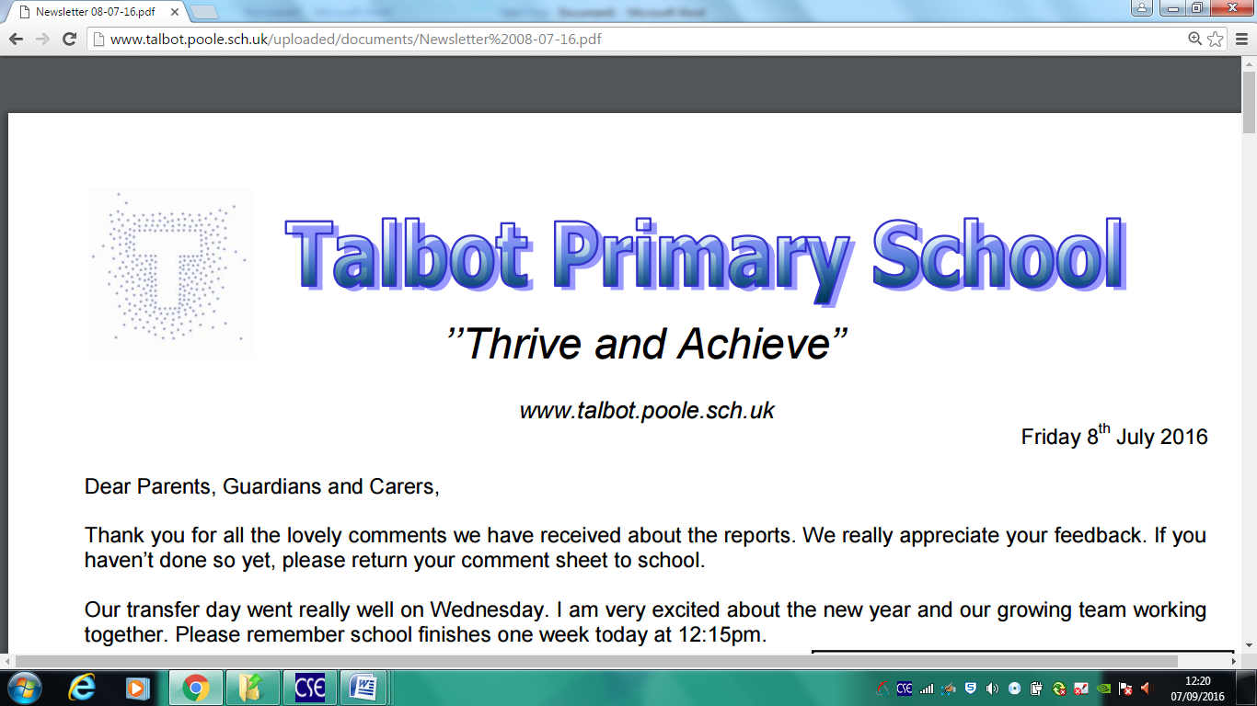
Communication and Language Progression map.

