Personal, Social and Emotional Development Matters Statements Coverage
AUTUMN | SPRING | SUMMER
See themselves as a valuable individual | Show resilience and perseverance in the face of challenge | Think about the perspectives of others
Manage their own needs | Identify and moderate their own feelings socially and emotionally
Build constructive and respectful relationships
Express their feelings and consider the feelings of others
Early Learning Goals
Personal, Social and Emotional Development
Self-Regulation
- Show an understanding of their own feelings and those of others, and begin to regulate their behaviour accordingly
- Set and work towards simple goals, being able to wait for what they want and control their immediate impulses when appropriate
- Give focused attention to what the teacher says, responding appropriately even when engaged in activity, and show an ability to follow instructions involving several ideas or actions
Managing Self
- Be confident to try new activities and show independence, resilience and perseverance in the face of challenge
- Explain the reasons for rules, know right from wrong and try to behave accordingly
- Manage their own basic hygiene and personal needs, including dressing, going to the toilet and understanding the importance of healthy food choices
Building Relationships
- Work and play cooperatively and take turns with others
- Form positive attachments to adults and friendships with peers
- Show sensitivity to their own and to others’ needs
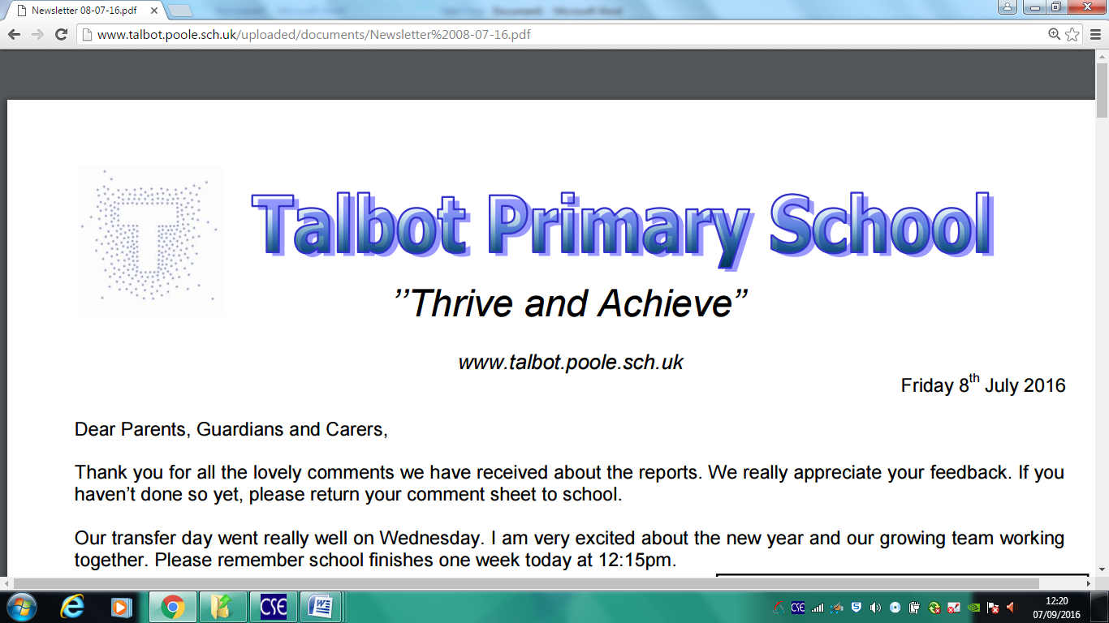
Personal Social and Emotional Progression map

