Physical Development Matters Statements Coverage
AUTUMN | SPRING | SUMMER
Revise and refine the fundamental movement skills they have already acquired;  - rolling  - crawling  - walking  - jumping  - running  - hopping  - skipping  - climbing | Develop their small motor skills so that they can use a range of tools competently, safely and confidently.  Suggested tools;  - pencils for drawing and writing  - paintbrushes  - scissors  - knives  - forks and spoons | Develop their small motor skills so that they can use a range of tools competently, safely and confidently.  Suggested tools;  - pencils for drawing and writing  - paintbrushes  - scissors  - knives  - forks and spoons
Use their core muscle strength to achieve a good posture when sitting at a table or sitting on the floor | Combine different movements with ease and fluency | Combine different movements with ease and fluency
Progress towards a more fluent style of moving, with developing control and grace | Develop the overall body strength, co-ordination, balance and agility needed to engage successfully with future physical education sessions and other physical disciplines, including dance, gymnastics, sport and swimming | Develop the overall body strength, co-ordination, balance and agility needed to engage successfully with future physical education sessions and other physical disciplines, including dance, gymnastics, sport and swimming
Early Learning Goals
Gross Motor Skills
- Negotiate space and obstacles safely, with consideration for themselves and others
- Demonstrate strength, balance and coordination when playing
- Move energetically, such as running, jumping, dancing, hopping, skipping and climbing
Fine Motor Skills
- Hold a pencil effectively in preparation for fluent writing – using the tripod grip in almost all cases
- Use a range of small tools, including scissors, paintbrushes and cutlery
- Begin to show accuracy and care when drawing
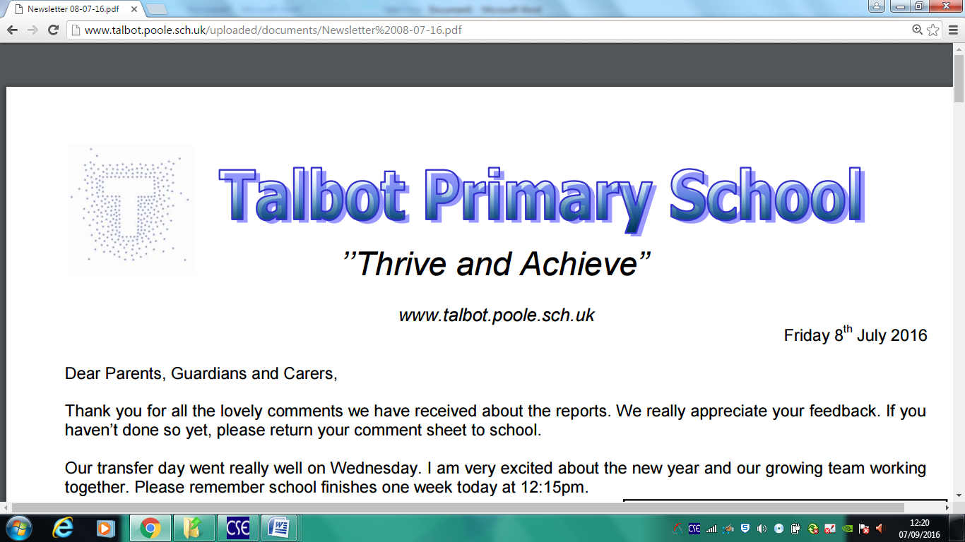
Physical Development Progression Map

