Using Kodu at home
- Visit this webpage https://www.microsoft.com/en-gb/download/details.aspx?id=10056
- Press the download button
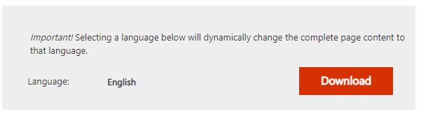
- Tick ‘KoduSetup.exe’ then press next
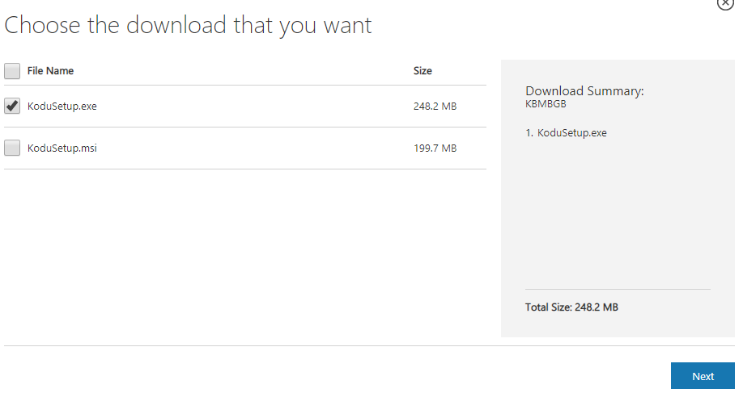
- Either click on the KoduSetup.exe file at the bottom of your browser window, or find it in your downloads folder and click it.
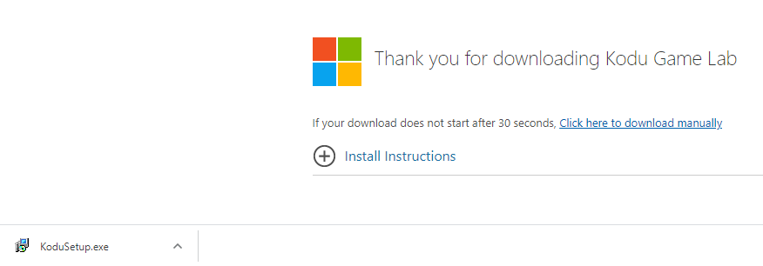
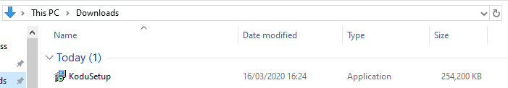
- Follow the rest of the download process.
- Children should choose a username that does not reveal their identity. They could use 2020 as a password that’s easy to remember.
- Children should work through each tutorial. These can be found by following these steps:
  - Log in
  - Go to ‘load world’
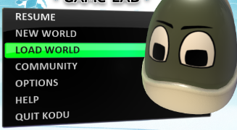
  - Click on lessons
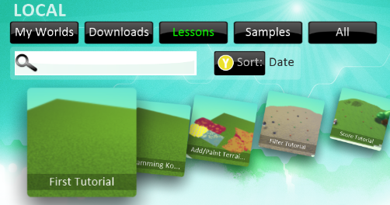
  - Follow the instructions along the top of the screen, example below:
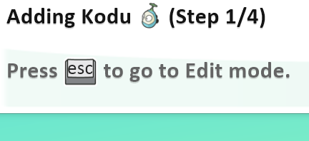
- When children have worked through all the tutorials, they can design their own game.

