/04/21
LO: To be able to recognise a third
WHITE
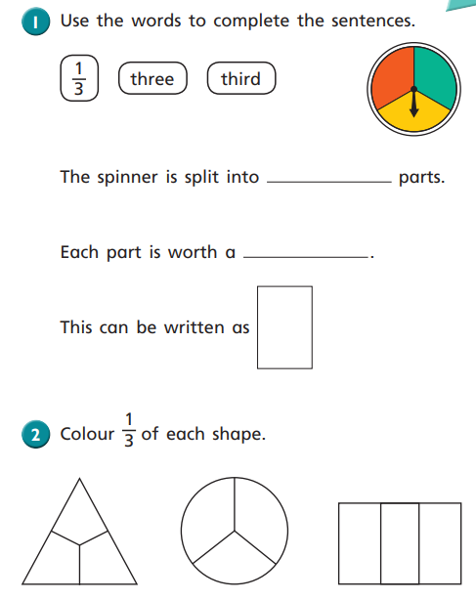
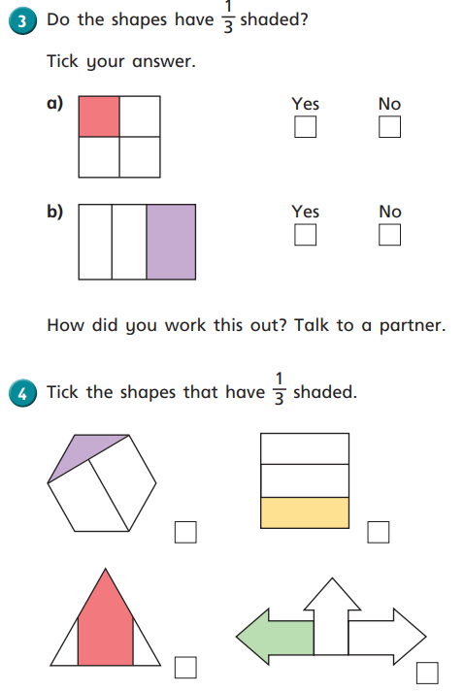

/04/21
LO: To be able to recognize a third
WHITE

/04/21
LO: To be able to recognize a third
YELLOW 1
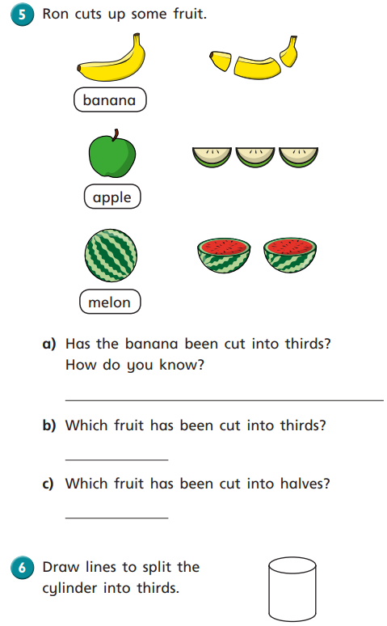
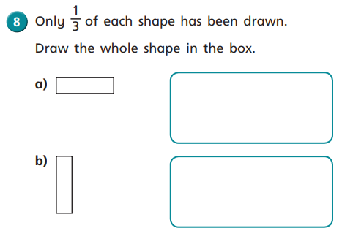

/04/21
LO: To be able to recognize a third
YELLOW 1

____/04/21
LO: To be able to recognize a third
Yellow 2
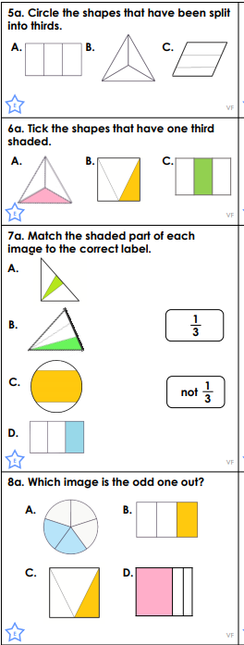

/04/21
LO: To be able to recognize a third
Yellow 2

/04/21
LO: To be able to recognize a third
Green
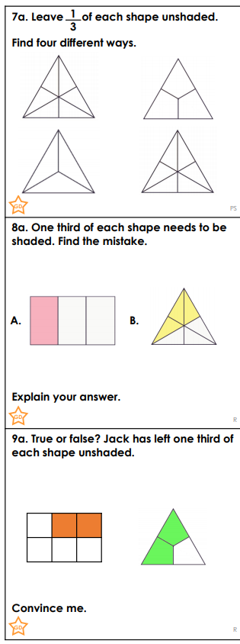

/04/21
LO: To be able to recognize a third
Green

