READING – 19/07/21

Read either a book on myOn or your school book. If you finish the book, complete a quiz on AR.

Writing - 19/07/21

Please carry this story on. Try to make it an interesting read and don’t forget your sentences.

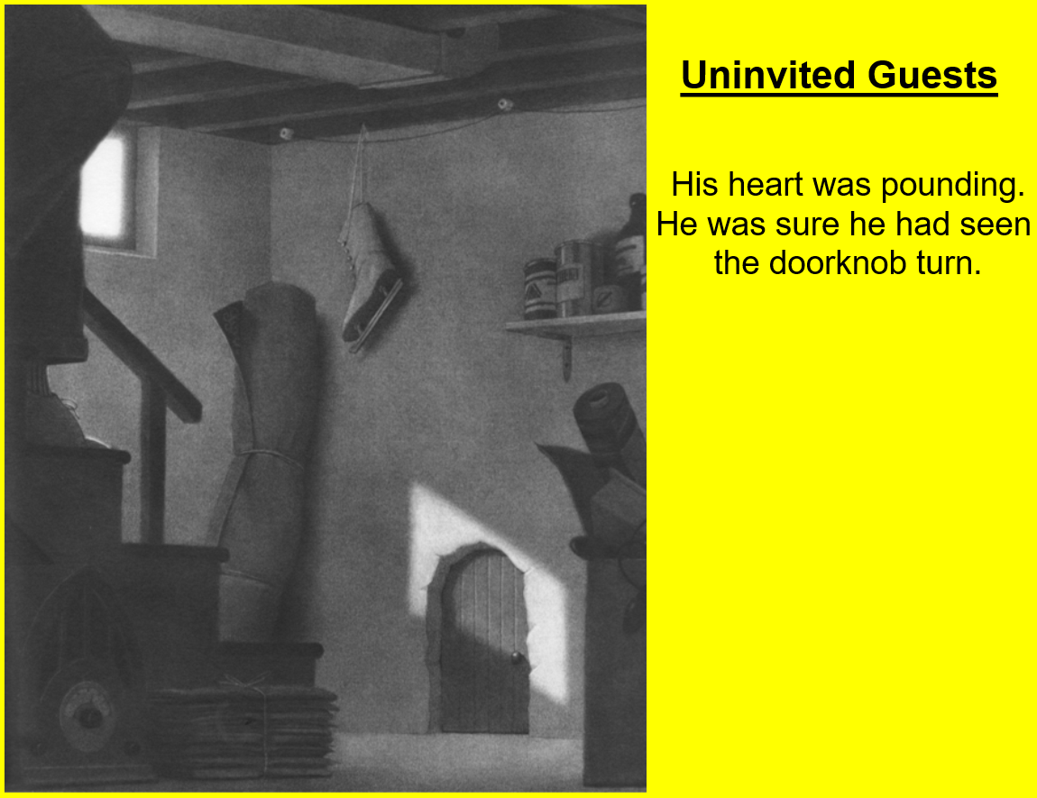
THINK IT – SAY IT – WRITE IT – READ IT

